NST21022 - Practical for Network Switching and Routing
Department of Information and Communication Technology
Faculty of Technology
Labsheet :08
Reg. Number: SEU/IS/20/ICT/084
Academic Year :2020/2021
Practical No :08

Title: IPv4 VLSM (Variable Length Subnet Mask)
Aim:
• VLSM IP addressing scheme
• Configure devices with IPv4 after subnetting
Task:
• Design an IP scheme
• Subnet the IPv4 address
• Assign IP address to Network devices and verify connectivity

Use “NST21022 Labsheet 08.pka” file Activities

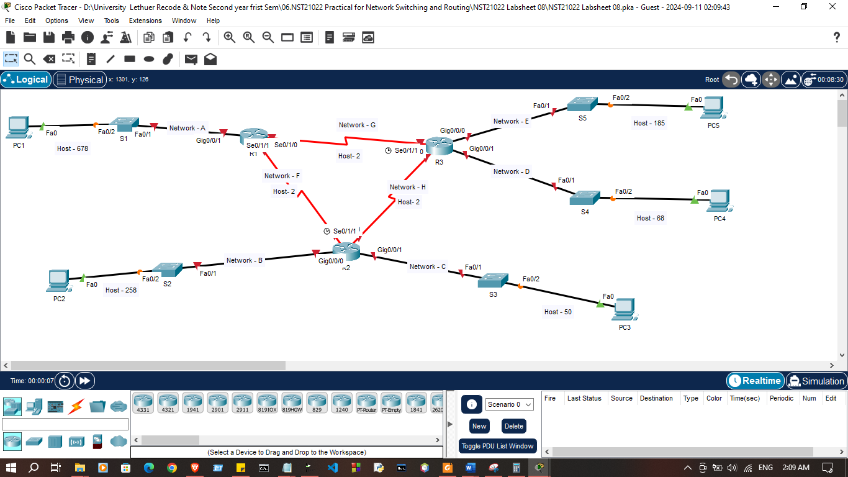

Exercise 01: Subnet the 172.16.0.0/16 network into the appropriate subnets.

1. Based on the topology, how many subnets were needed?

- 8 subnets

2. How many hosts need for each subnet?

- Subnet A:-678
- Subnet B:-258
- Subnet C:-50
- Subnet D:-68
- Subnet E:-185
- Subnet F :-2
- Subnet G:-2
- Subnet H:-2

3. How many hosts provide by each subnet?

- Subnet 1:-1024
- Subnet 2:-512
- Subnet 3:-64
- Subnet 4:-256
- Subnet 5:-128
- Subnet 6 :-4
- Subnet 7:-4
- Subnet 8:-4

Exercise 02: Fill the subnet table.

Subnet Number | Network Address | First Usable Host Address | Last Usable Host Address | Broadcast Address
A | 172.16.0.0 | 172.16.0.1 | 172.16.0.0 | 172.16.3.255
B | 172.16.4.0 | 172.16.4.1 | 172.16.0.0 | 172.16.5.255
C | 172.16.7.128 | 172.16.7.129 | 172.16.0.0 | 172.16.7.191
D | 172.16.7.0 | 172.16.7.1 | 172.16.0.0 | 172.16.7.121
E | 172.16.6.0 | 172.16.6.1 | 172.16.0.0 | 172.16.6.255
F | 172.16.7.192 | 172.16.7.193 | 172.16.7.194 | 172.16.7.195
G | 172.16.7.196 | 172.16.7.197 | 172.16.7.198 | 172.16.7.199
H | 172.16.7.200 | 172.16.7.201 | 172.16.7.202 | 172.16.7.203

Exercise 03: Configure IP address according to following criteria.
1. Fill the addressing table using following guidelines:
a. Assign the first usable IP addresses in each subnet to R1, R2, R3 for
the LAN links.
b. Assign the first usable IP addresses in each subnet for the WAN links
as follows;
R1 – S0/1/0
R1 – S0/1/1
R2 – S0/1/1
c. Assign the last usable IP addresses in each subnet for the WAN links as follows.
R2 – S0/1/0
R3 – S0/1/0
R3 – S0/1/1

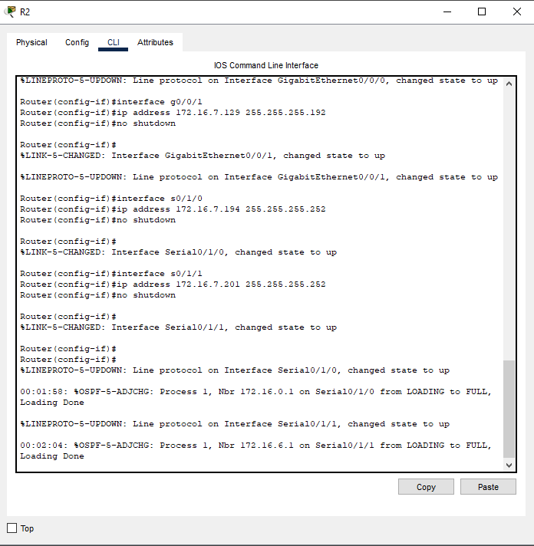
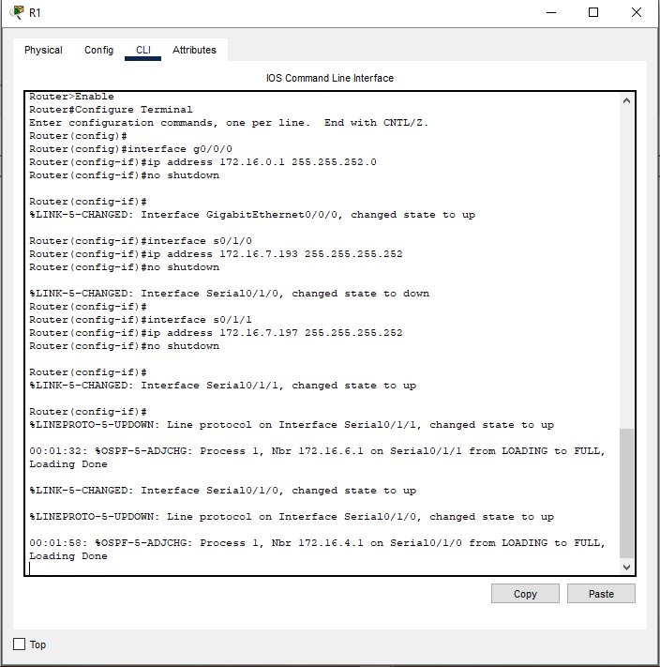

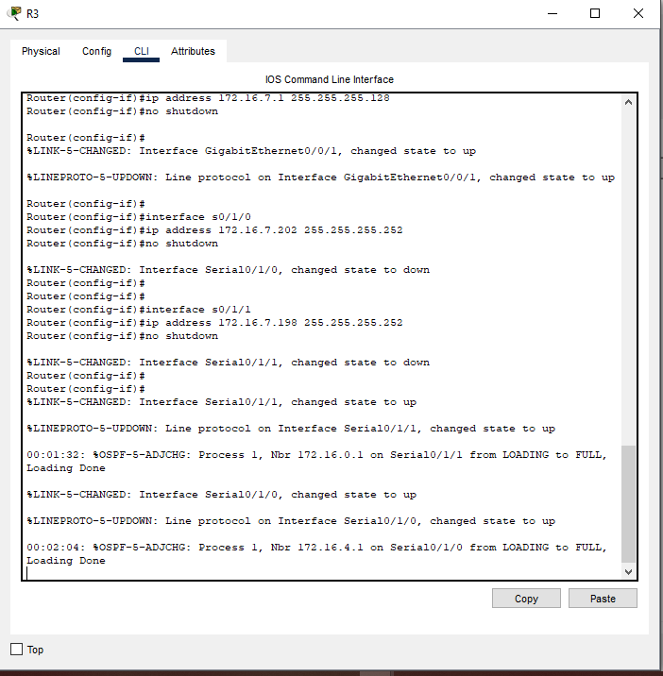

d. Assign the second usable IP address to the PCs in each subnet
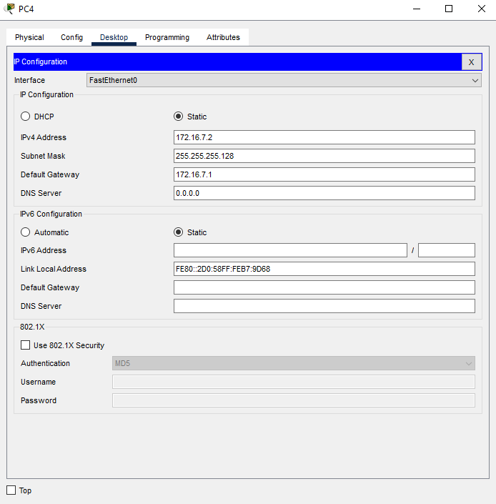
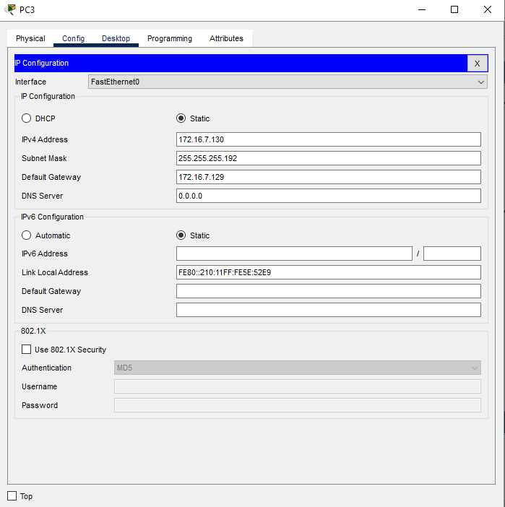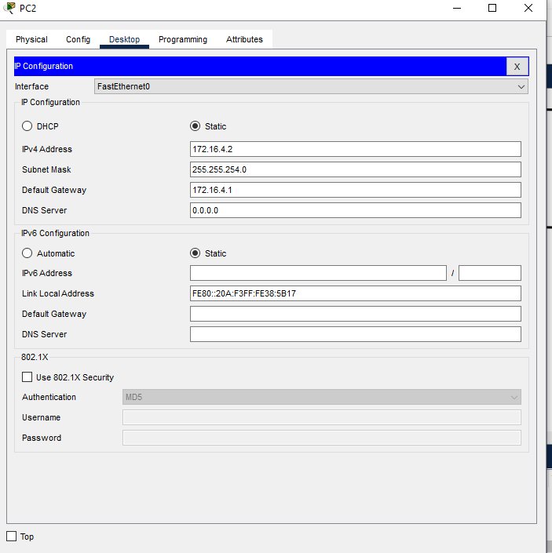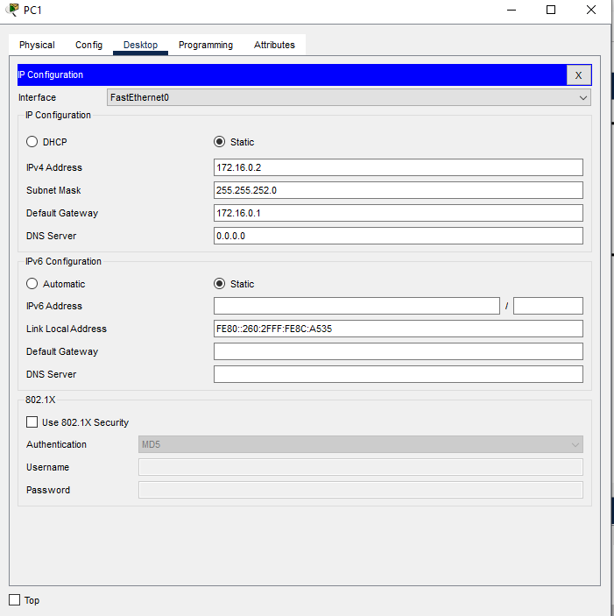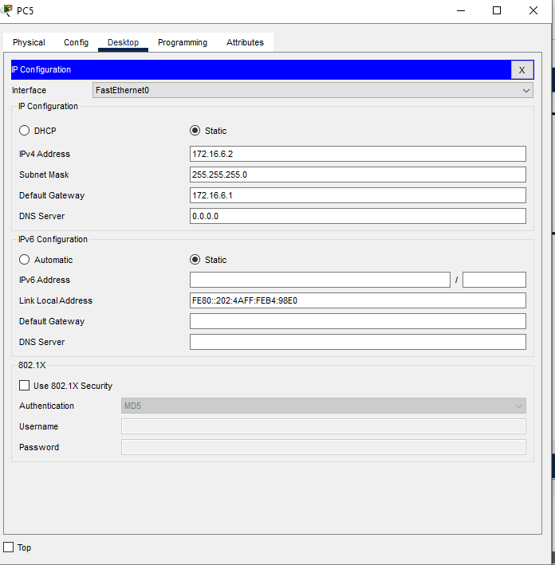

Addressing Table
Devices | Interfaces | IP Addresses | Subnet Mask | Default Gateway
R1 | G0/0/0 | 172.16.0.1 | 255.255.252.0
R1 | S0/1/0 | 172.16.7.193 | 255.255.255.252
R1 | S0/1/1 | 172.16.7.197 | 255.255.255.252
R2 | G0/0/0 | 172.16.4.1 | 255.255.254.0
R2 | G0/0/1 | 172.16.7.129 | 255.255.255.192
R2 | S0/1/0 | 172.16.7.194 | 255.255.255.252
R2 | S0/1/1 | 172.16.7.201 | 255.255.255.252
R3 | G0/0/0 | 172.16.6.1 | 255.255.255.128
R3 | G0/0/1 | 172.16.7.1 | 255.255.255.0
R3 | S0/1/0 | 172.16.7.202 | 255.255.255.252
R3 | S0/1/1 | 172.16.7.198 | 255.255.255.252
PC1 | NIC | 172.16.0.2 | 255.255.252.0 | 172.16.0.1
PC2 | NIC | 172.16.4.2 | 255.255.254.0 | 172.16.4.1
PC3 | NIC | 172.16.4.130 | 255.255.255.192 | 172.16.4.129
PC4 | NIC | 172.16.7.2 | 255.255.255.192 | 172.16.7.1
PC5 | NIC | 172.16.6.2 | 255.255.255.0 | 172.16.6.1

2. Assign IP addresses to network devices and verify connectivity
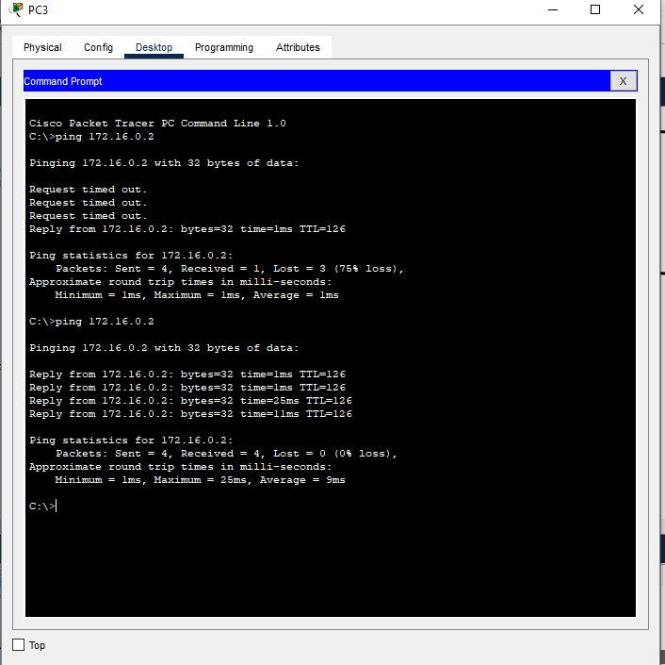

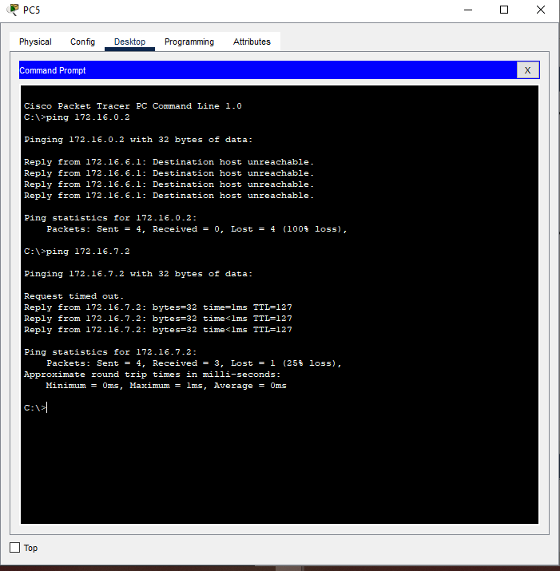

Discussion:
- In this lab session, we focused on implementing the Variable Length Subnet Mask (VLSM) to design an efficient IPv4 addressing scheme. The aim was to optimize the use of IP addresses by assigning subnet sizes according to the specific needs of each network segment. We began by designing an IP scheme that accounted for varying numbers of hosts in each subnet, allowing us to allocate IP addresses more effectively. After subnetting the IPv4 address using VLSM, we assigned IP addresses to the network devices such as routers, switches, and hosts. Finally, we tested the network by verifying connectivity between devices within each subnet and across different subnets. This session highlighted the benefits of VLSM in conserving IP address space and improving network scalability.

